DocuSign Walkthrough

After the Sales Rep has received approval from their manager, they send the Order Form request:

Recipients:
- “Sales – Order Forms”
- Sales Manager

Subject Line:
- “Order Form/Addendum/NDA Product Account” (i.e Order Form MA Lauren’s Test Account)

Email Contents:
- Account Name
- Link to Opportunity in SFDC
- Name & Email Address of Signer (exactly as they appear in SFDC)
- Name & Email Address of anyone to be cc’d ((exactly as they appear in SFDC)
- Any important notes regarding the deal
- Attached Order Form
  - (Naming convention: Order Form/Addendum/NDA Product Account Date, i.e “Order Form_MA_Lauren’s Test Account_092818”)
- Number of days in which the envelope should expire (if applicable). Default is 30 days.

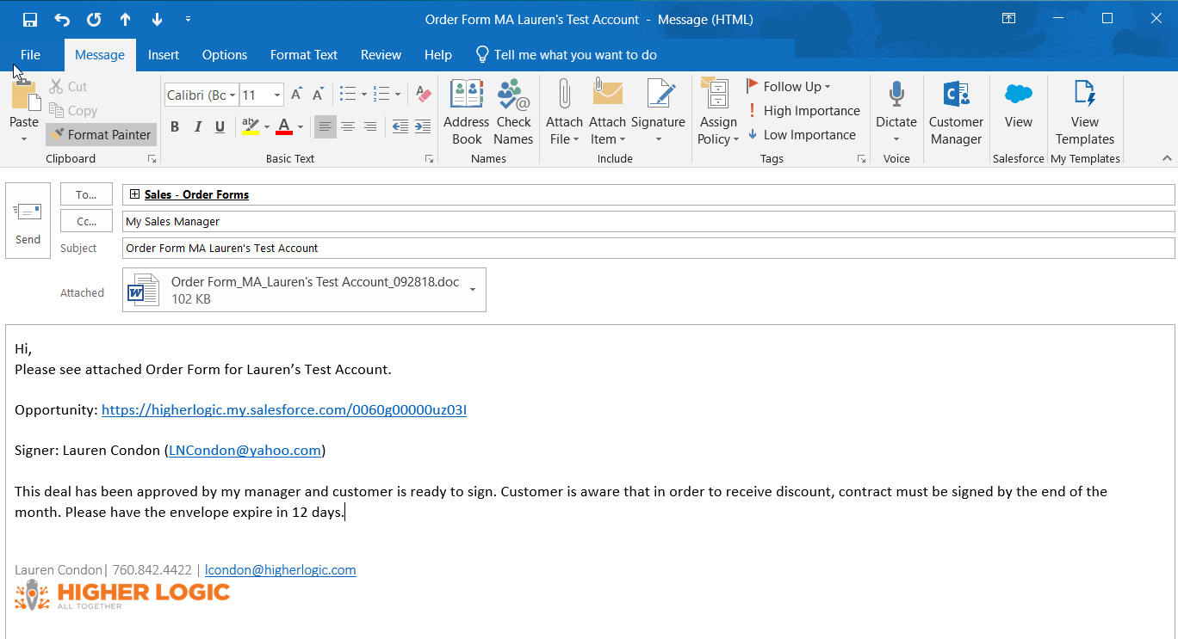

Sales Ops receives the email and reviews the Order Form. Once the Order Form has been approved by Megan Caldwell, it is ready to be uploaded into SFDC via the Opportunity:

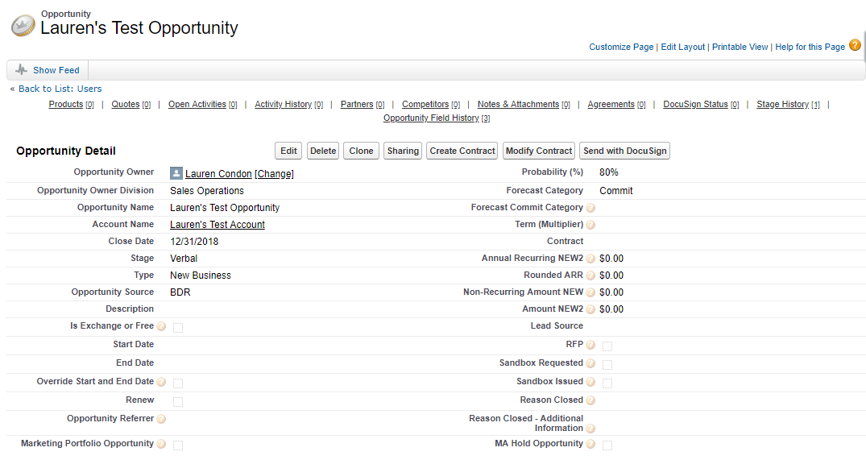

The Order Form is attached, the Account Name (taken from the Opportunity) is added to the Subject Line and the requested Recipients are added. The envelope is also given a number of days in which it will expire (if applicable). Please note: The Name of any recipient must be provided EXACTLY as it appears in SFDC, otherwise, it will not be found by DocuSign.

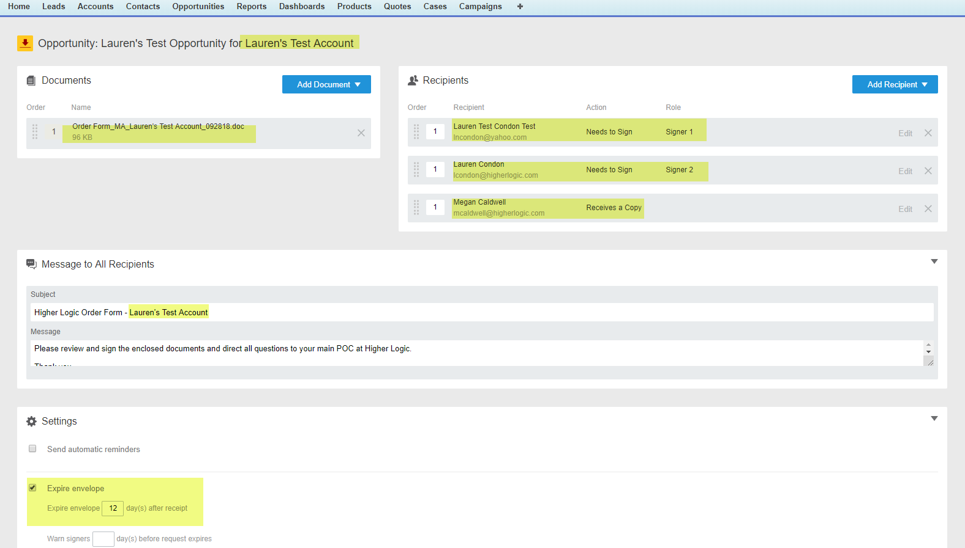

On the Order Form, the fields for Signature, Date Signed, Name, Full Title, and Email are added for both signers and then the Envelope is sent.

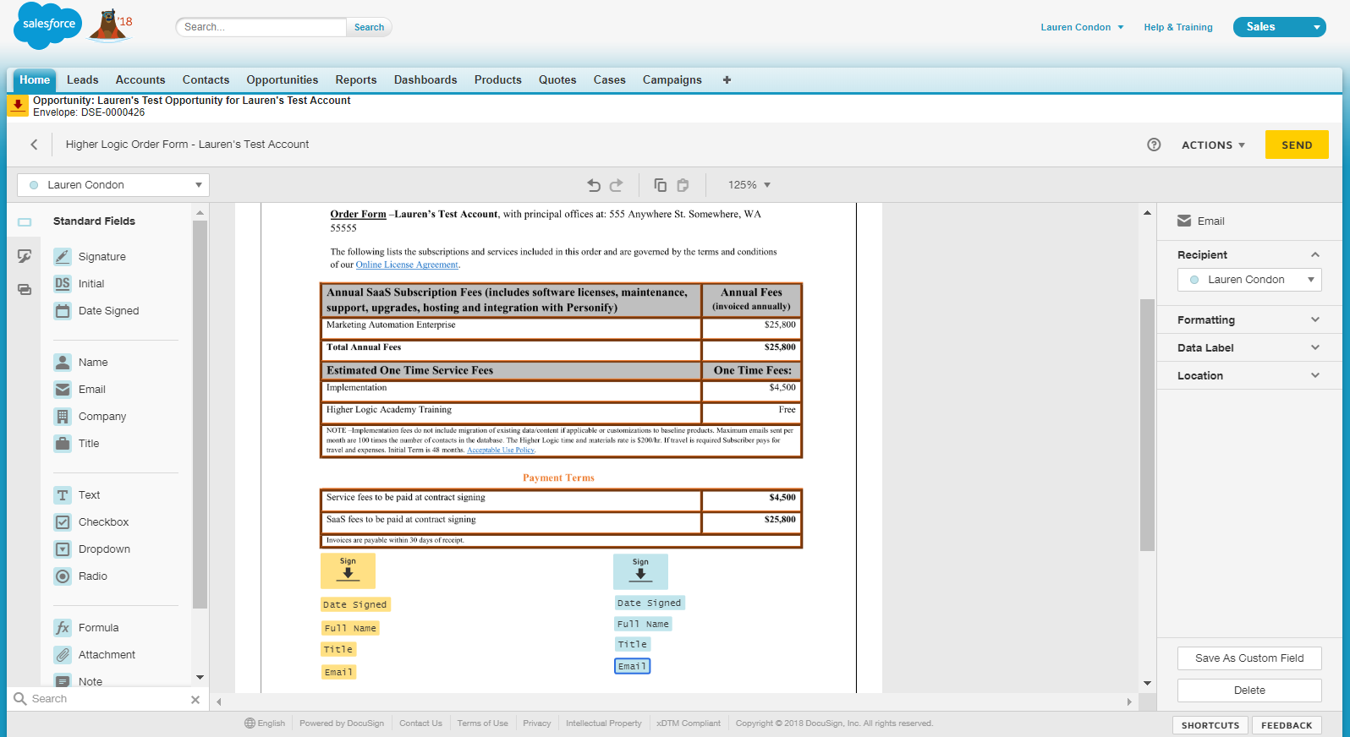

All parties receive an email from the Envelope sender (Sales Ops):

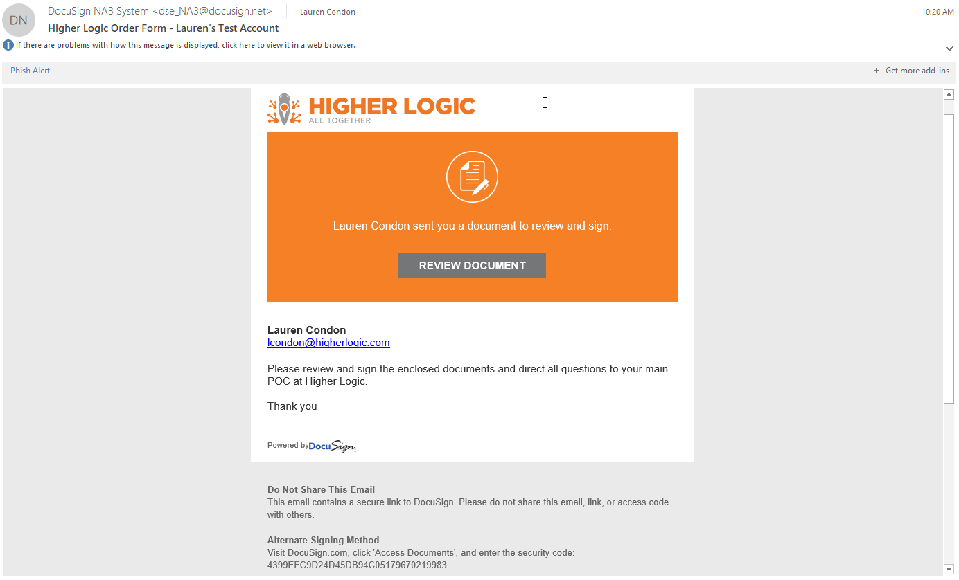
When the recipient clicks on the “Review Document” button, they will be taken to an external DocuSign link where they will need to read and agree to the Disclosure and click the “Continue” button

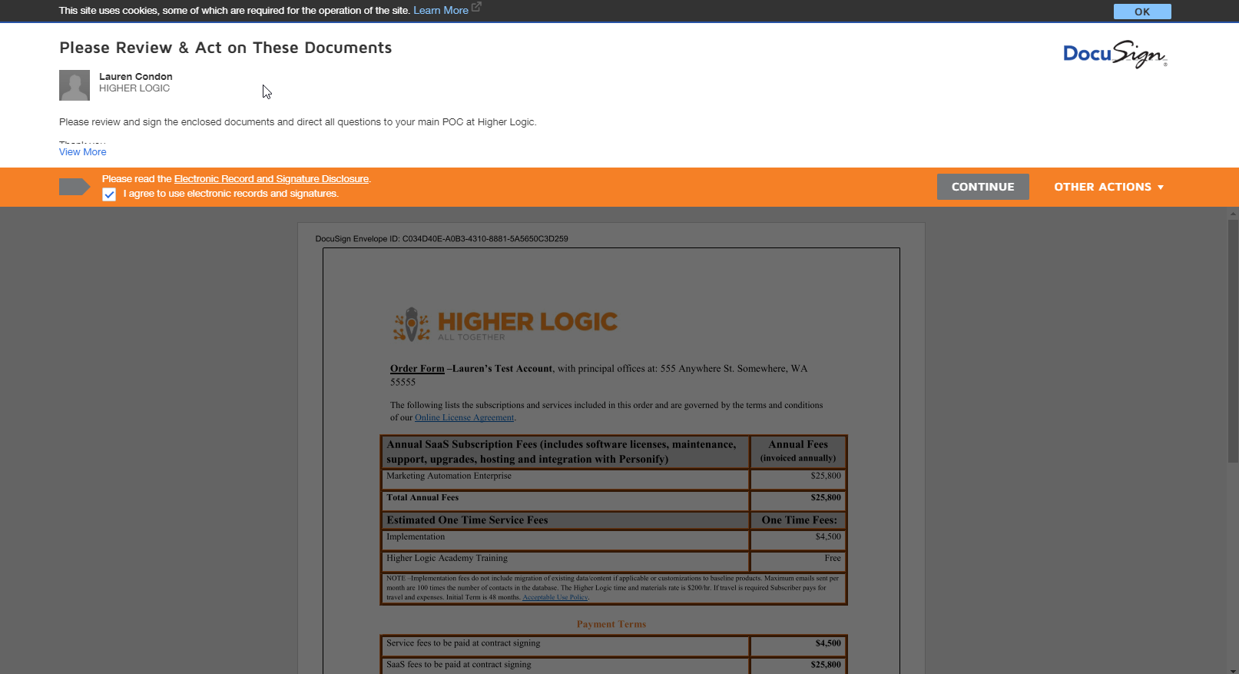

They will then be taken to the Order Form for signing. Upon clicking the “Start” button, the arrow will guide the signer to the appropriate signing area.

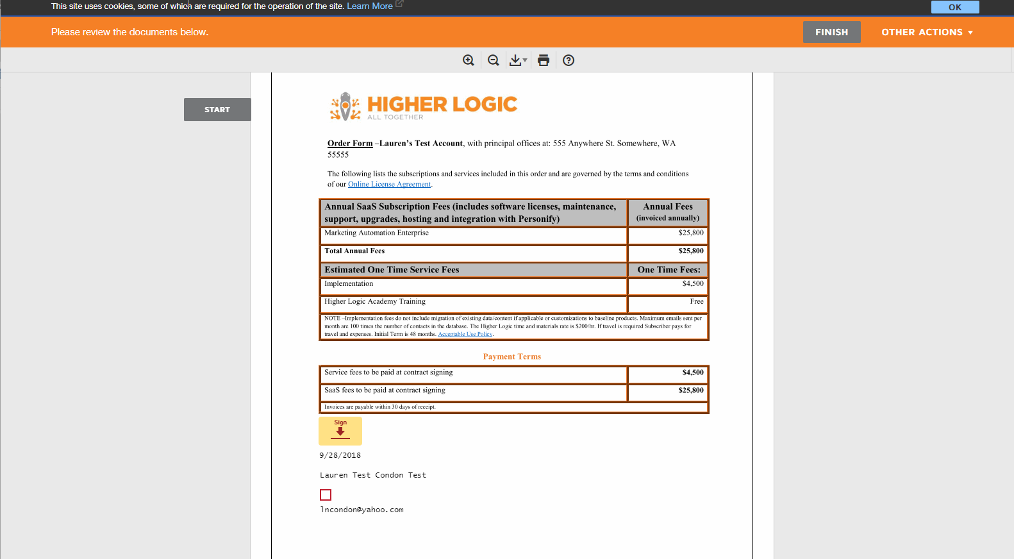

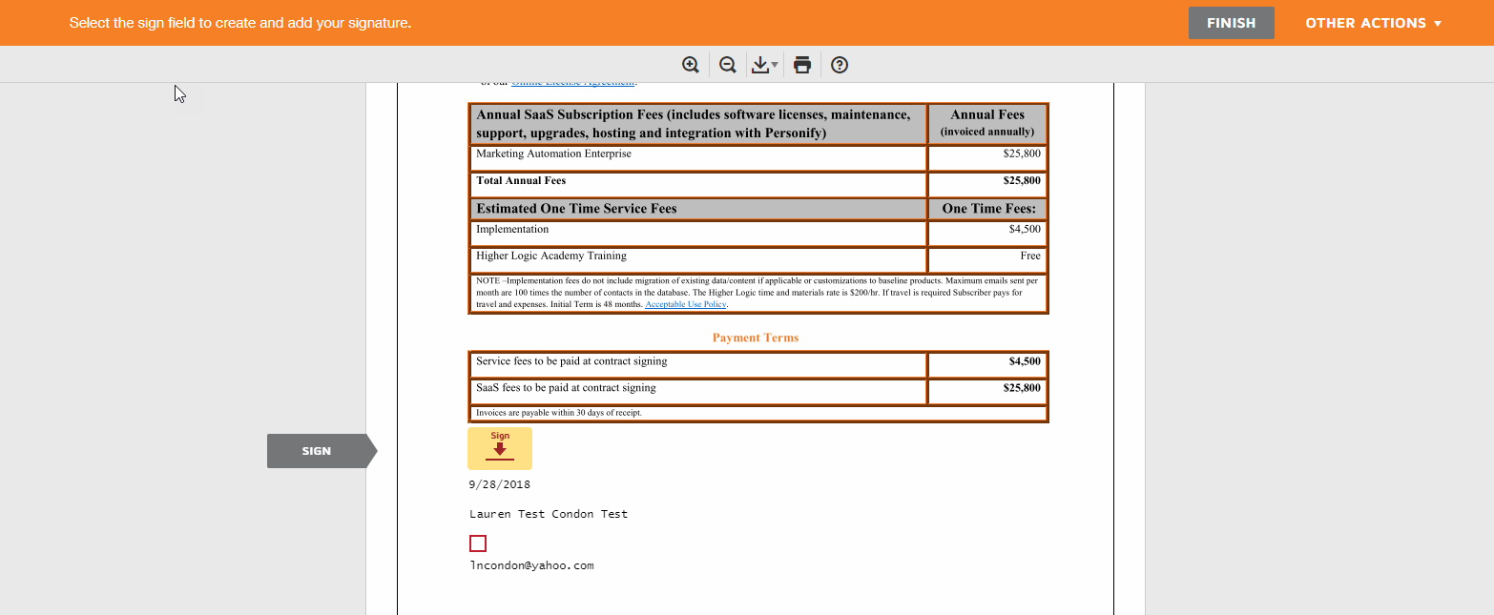

If the recipient has elected to have another employee to sign the document, they can go to the “Other Actions” drop-down menu and select “Assign to Someone Else.”

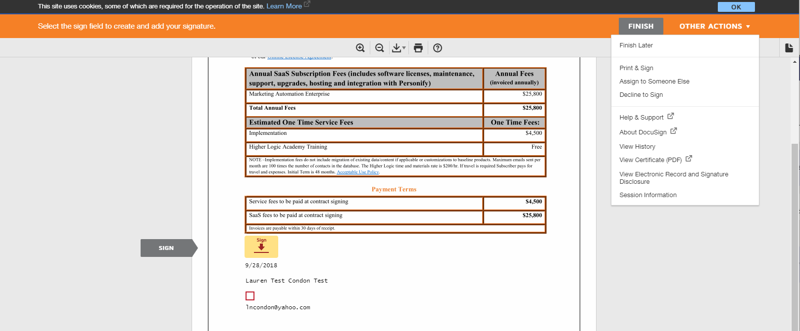

The person will need to enter the Name and Email Address of the person they want to transfer signing power to, as well as a reason for the change: (The following link can be sent to the customer should they require additional directions: https://support.docusign.com/guides/signer-guide-signing-other-actions-new)

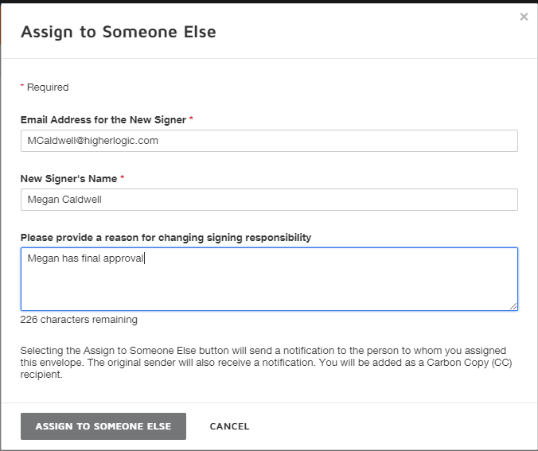

If the recipient has elected not to sign electronically, they can go to the “Other Actions” drop-down menu and select “Print & Sign”:

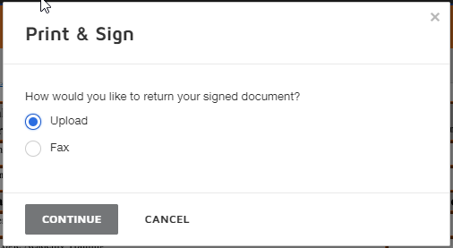

When the signer clicks on the “Sign” button, they will be taken to a window which will give them the option of selecting a pre-created style for their signature or drawing their signature:

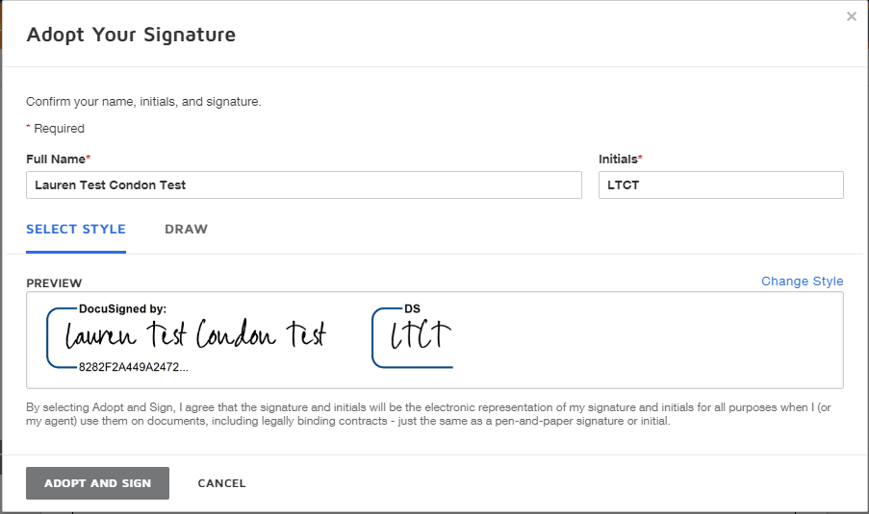

Upon making their selection and clicking the “Adopt And Sign” button, their signature will be recorded on the Order Form. Then they need to click the “Next” button to fill their title (if the information is not already in SFDC) and click the “Finish” button:

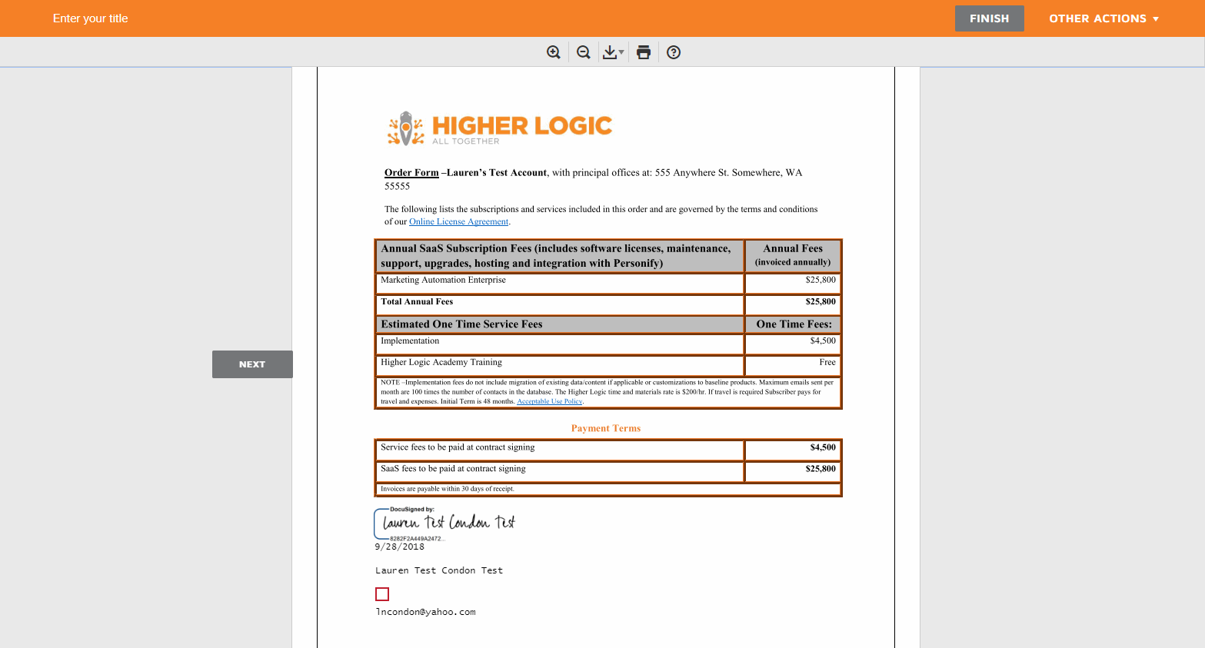

The signer will then be informed of next steps:

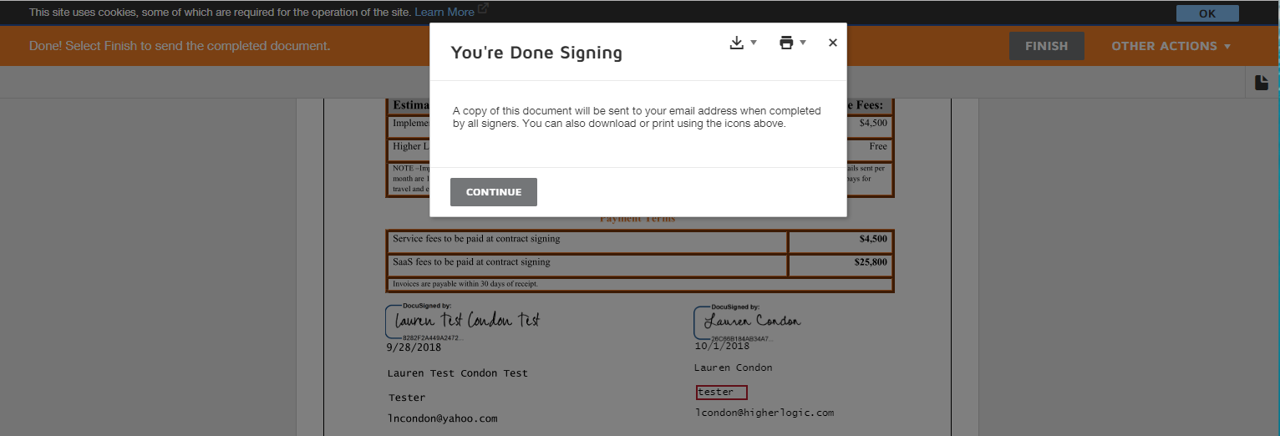

Upon both parties signing, all recipients will receive a notification that the envelope has been “completed.” This message also contains the final, signed, pdf version of the Order Form. They can also click on the “View Completed Document” button which will takes them to into DocuSign to view the document.

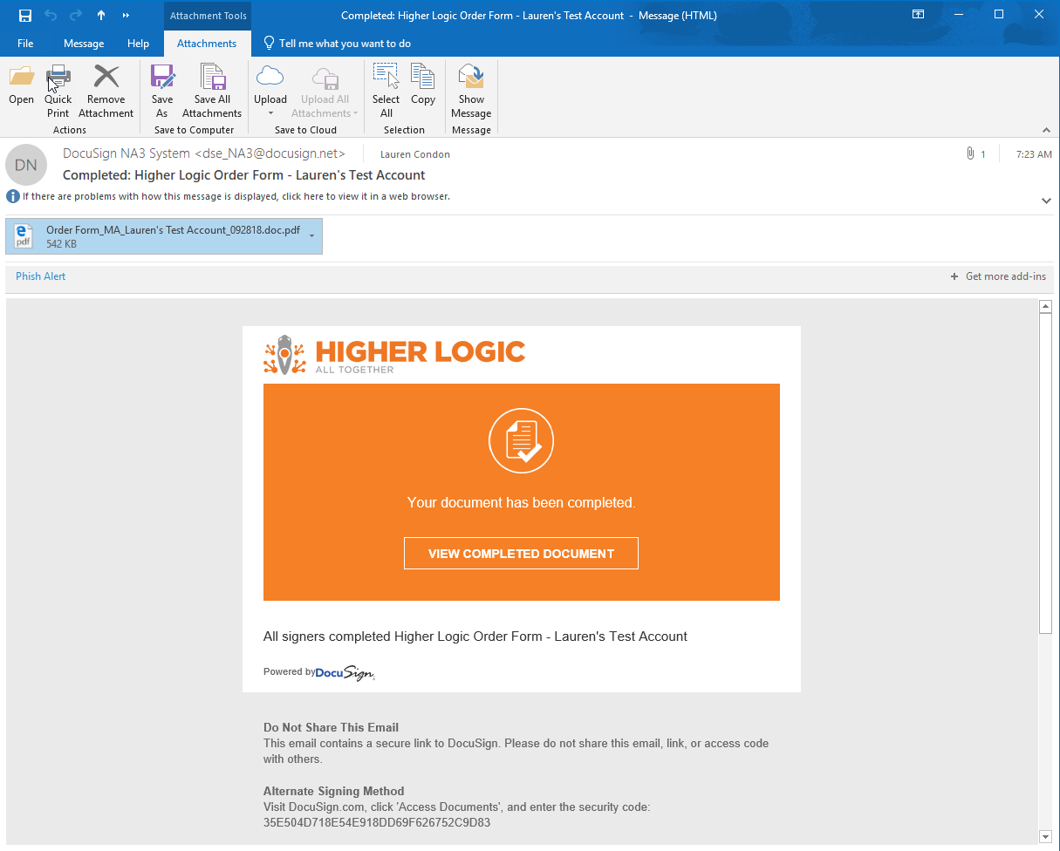
They can also click on the “View Completed Document” button which will takes them to into DocuSign to view the document.

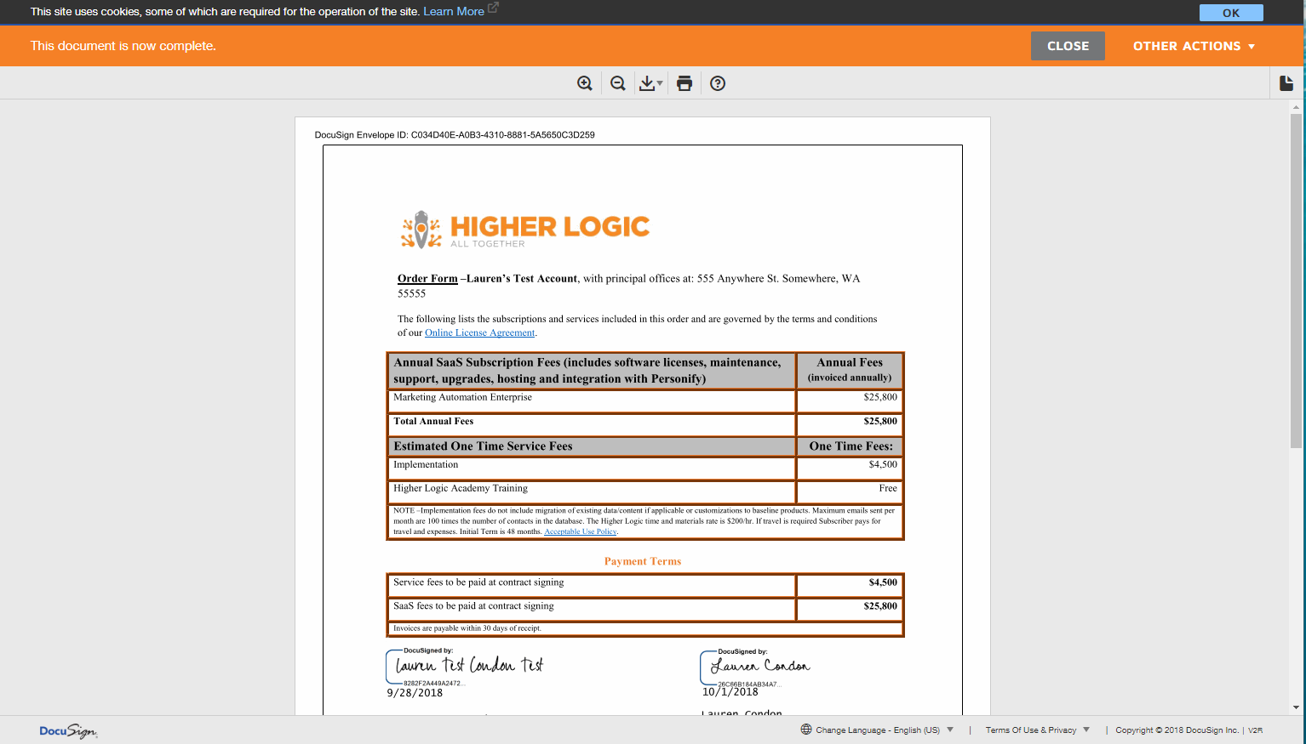

The Sales Rep can also view the Date and Time at which the Envelope was signed by all parties within the “DocuSign Status” section on the Account or Opportunity Page by click on the hyperlinked “Envelope #”

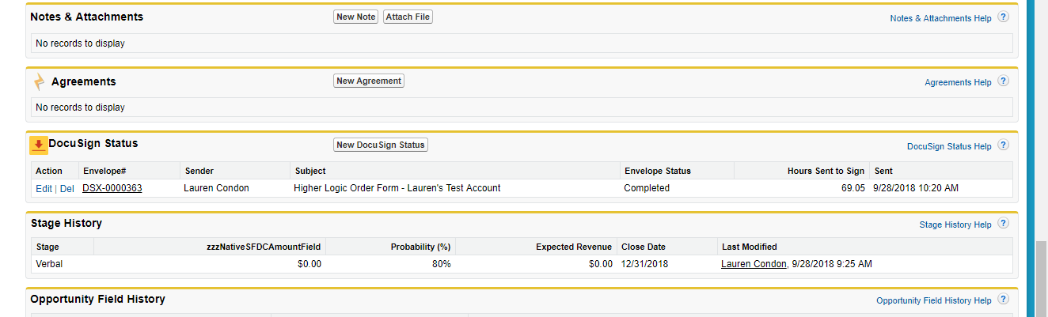

From there, the Sales Rep can view all information regarding the envelope. The Sales Rep can also access the final, signed, PDF version of the Order Form from the “Notes & Attachments” section:

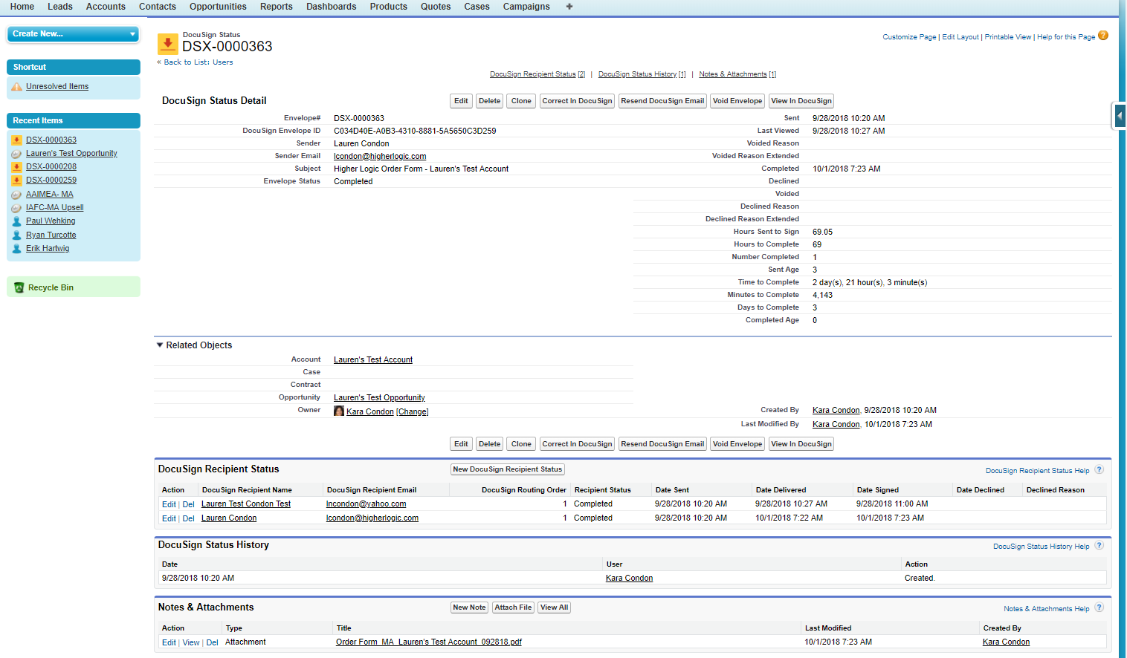

If at any point during the Order Form process the Sales Rep has any questions about the status of the Order Form/Envelope, they should first check the “DocuSign Status” section and the “DocuSign FAQs” document on the “Order Forms” page in HL Staff. If they still have questions, they can reach out to Sales Ops and provide the link to the Opportunity in question.

